Garett Wilson

Data Mining II

**Analysis of UCDP/PRIO Armed Conflict Dataset**

Table of Contents

Introduction to the dataset 1

Data Dictionary 1

Exploratory Data Analysis 3

Data Mining and Methods 8

Clustering 8

Sentiment analysis and results 12

Predicting 14

Performance 15

Summary 17

### Introduction to the dataset

In this analysis I am working with the Uppsala Conflict Data Program (UCDP) based out of Uppsala University in Sweden, and the Peace Research Institute in Oslo’s (PRIO) *armed conflict dataset.* UCDP has been collecting armed conflict data for around 40 years, beginning in the 1980s with the goal of enabling research on peace and conflict studies. A conflict in this dataset is defined as, an armed conflict using manufactured arms, sticks or even stones between two parties in which at least one of the parties is a government or state resulting in 25 or more total deaths in a single calendar year.

### Data Dictionary

This dataset contains roughly 135,000 conflict entries and 42 variables, with around 9.9% missing data. The 42 variables can be seen below for reference once we get into the analysis. As a high-level overview, each conflict event has a unique ID, however the conflict itself or conflict_name, will appear multiple times. The dataset is built out using a hierarchy for example, the Afghanistan war happened in the country of Afghanistan, within that war multiple conflicts happened, and within each conflict multiple events occurred that involved fighting within different regions and districts of the country. They all roll into each other, with the highest point of the hierarchy being country. We can determine the severity of each conflict by using one of the several metrics included for measuring deaths such as deaths_side_a, deaths_side_b, deaths_civilians, unknown_deaths, high, low, and best.

| **Column Name** | **Type** | **Description** |
| --- | --- | --- |
| id | Integer | Unique event identifier |
| year | Integer | Year of the event |
| active_year | Integer | Year when the conflict was active (may differ from event year) |
| type_of_violence | Integer | Type of violence: 1 = State-based conflict 2 = Non-state conflict 3 = One-sided violence |
| conflict_new_id | Integer | Unique ID for the conflict (updated/revised) |
| conflict_name | String | Name of the conflict |
| dyad_new_id | Integer | Unique ID for the dyad (pair of actors involved) |
| dyad_name | String | Name of the dyad (pair of actors) |
| side_a_new_id | Integer | Unique ID for Side A actor |
| gwnoa | Integer | Gleditsch–Ward country code for Side A |
| side_a | String | Name of primary actor on Side A (government or other) |
| side_b_new_id | Integer | Unique ID for Side B actor |
| gwnob | Integer | Gleditsch–Ward country code for Side B |
| side_b | String | Name of primary actor on Side B (rebel, opposition, state) |
| number_of_sources | Integer | Number of sources reporting this event |
| source_article | String | Source article citation or URL |
| source_office | String | News office or agency source |
| source_date | Date/String | Date of source publication |
| source_headline | String | Headline of the source article |
| source_original | String | Original source text excerpt |
| where_prec | Integer | Precision level of the location data |
| where_coordinates | String | Coordinates (latitude, longitude) of event location |
| adm_1 | String | First-level administrative unit (e.g., state/province) |
| adm_2 | String | Second-level administrative unit (e.g., county/district) |
| latitude | Float | Latitude of event location |
| longitude | Float | Longitude of event location |
| geom_wkt | String | Geometry in WKT (Well-Known Text) format representing location shape |
| priogrid_gid | Integer | PRIO-GRID cell ID (spatial grid cell) |
| country | String | Country name of the event location |
| country_id | Integer | Country code or ID |
| region | Integer | Numeric region code (e.g., 1 = Europe, 2 = Middle East, etc.) |
| event_clarity | Integer | Clarity or certainty level of the event data |
| date_prec | Integer | Precision of event date: 1 = Day 2 = Month 3 = Year |
| date_start | Date | Start date of the event or conflict episode |
| date_end | Date | End date of the event or conflict episode |
| deaths_a | Integer | Estimated deaths for Side A (low estimate) |
| deaths_b | Integer | Estimated deaths for Side B (low estimate) |
| deaths_civilians | Integer | Estimated civilian deaths (low estimate) |
| deaths_unknown | Integer | Estimated deaths of unknown affiliation |
| best | Integer | Best estimate of total deaths from the event |
| low | Integer | Low estimate of total deaths |
| high | Integer | High estimate of total deaths |

### Exploratory Data Analysis

This section will cover some key contents of this dataset and its variables. The conflict data ranges from 1989-2016 (28 years), with most of the data coming from 2004 onward. Most likely due to conflicts increasing in modern days with the advancements of technology and weapons, but also the increase in the availability of data.

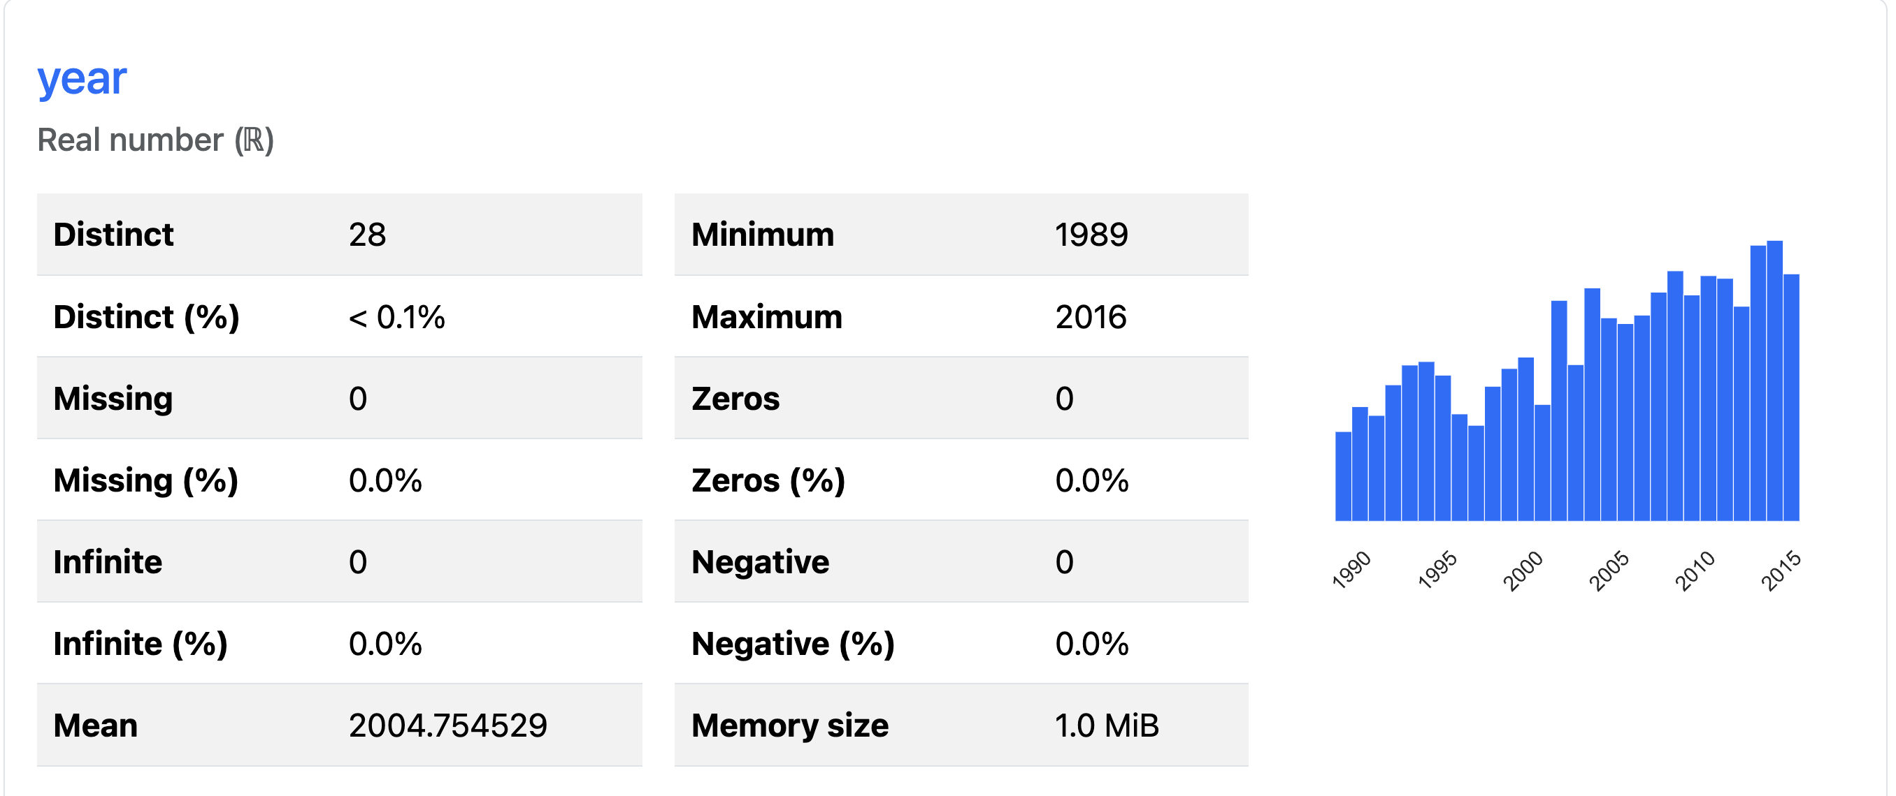

Out of the 135,000 entries in this dataset, there are only 997 unique conflicts, with most of them involving civilians and governments.

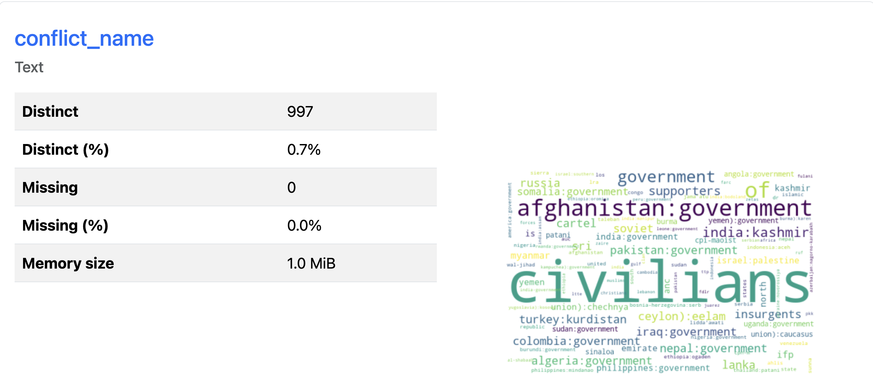

117 countries are covered in this dataset, with Afghanistan showing up the most, which make sense considering the Afghan war spanned 20+ years.

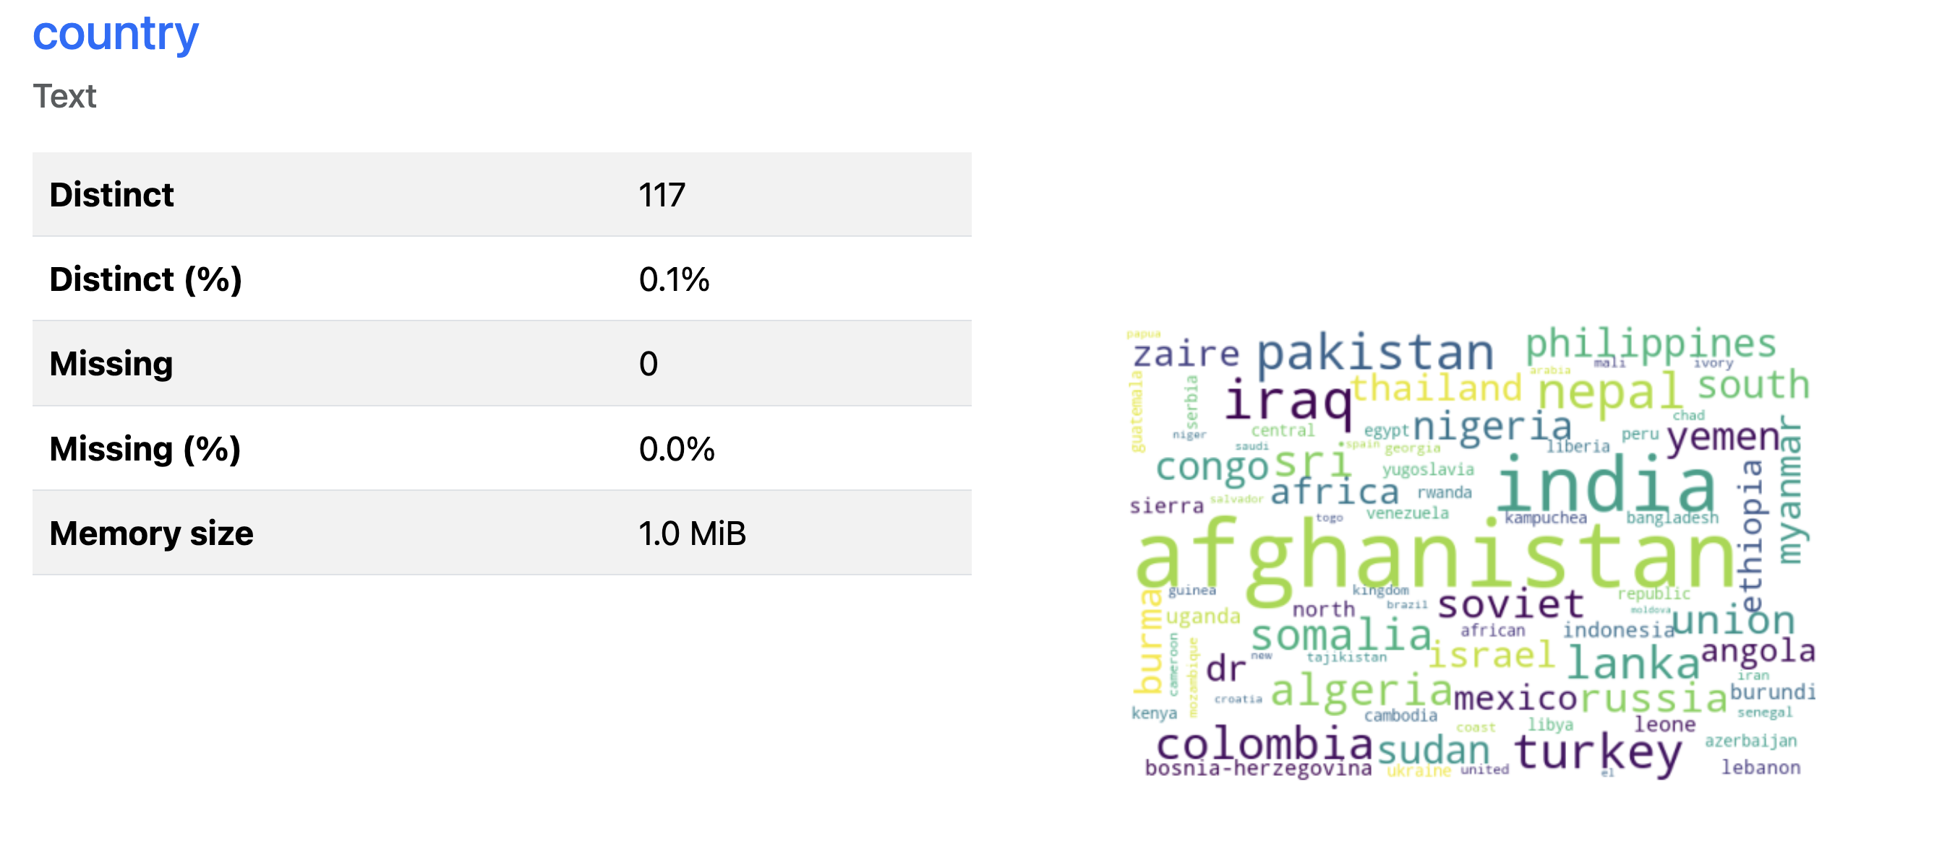

Out of all the death metrics, high is the one with the least number of 0’s, or in other words it is the most complete prediction. High represents the high side of the total number of deaths in the individual event of the conflict. It is important to note, below we see the max deaths being 547,077 however, that is not indicative of the total deaths for an entire conflict, just that of the specific event inside of the entire conflict. The total deaths for the entirety of the dataset are 2,906,495.

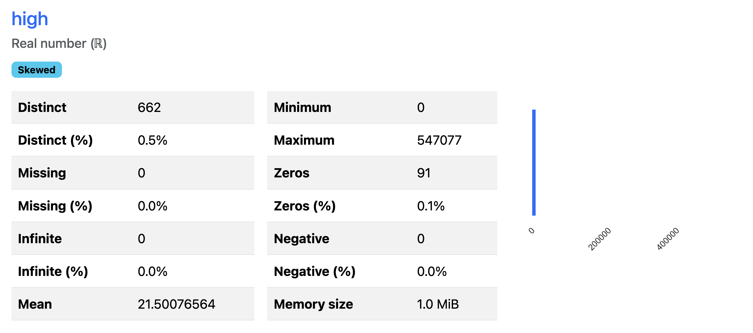

We can see here, the country of **Rwanda** has the greatest number of deaths out of the conflicts at roughly 816,000 , and Afghanistan in second at around 217,000. This number of deaths in Rwanda (816,788), a country in Africa was due to the Rwanda Civil War and Genocide between 1990 and 1994. The war was fought by the Rwanda Armed Forces (the government) and the Rwandan Patriot Front (civilians). Hutu was leading the government, and the Tutsi were the civilians. There was fighting between the two groups starting in 1990, with neither able to gain the upper hand through 1992 when peace talks began and the peace accord was signed. The RPF started implementing the accord in 1993 ending the civil war. Following the civil war the Rwandan Genocide began between the Tutsi and the Hutu, where around 816k Tutsi were killed within 100 days leading into 1994 because of ethnic tensions between the two groups. The RPF then reignited the civil war because of these genocides and eventually defeated and took control of the government.

**Afghanistan vs the Government** - the Afghan war lasted from 2001-2021. It began in 2001 following the September 11th (9/11) attacks by al-Qaeda in U.S. soil on the twin towers, pentagon, and one failed attack. The war was in 3 phases, the first phase toppling the Taliban who ruled Afghanistan and provided sanctuary for al-Qaeda - which one lasted two months. The second phase from 2002-2008 was marked by US strategy of defeating Taliban militarily and rebuilding core institutions of the Afghan state. Around 2009 The large force of US troops was sent there to protect the population from Afghan attacks until the responsibility could be handed over to the Afghan security forces. The government of Afghanistan which was backed by the US and NATO vs the Taliban, and 2010 was the bloodiest year of the war.

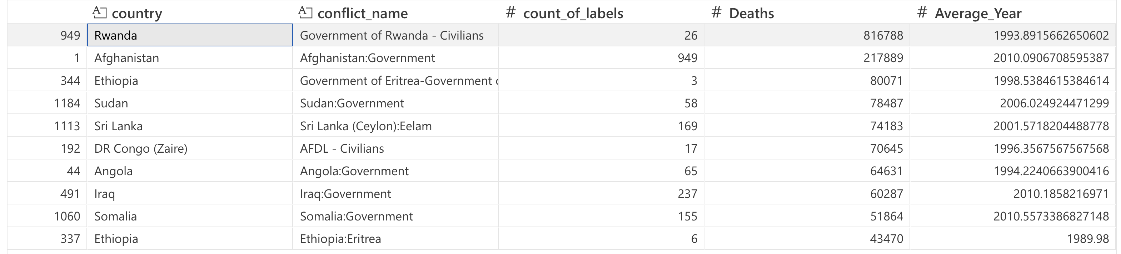

Below is an additional view of the countries with the most deaths, with Rwanda being an outlier here. We also see Afghanistan, DR Congo, Ethiopia, Israel, and Switzerland standing out.

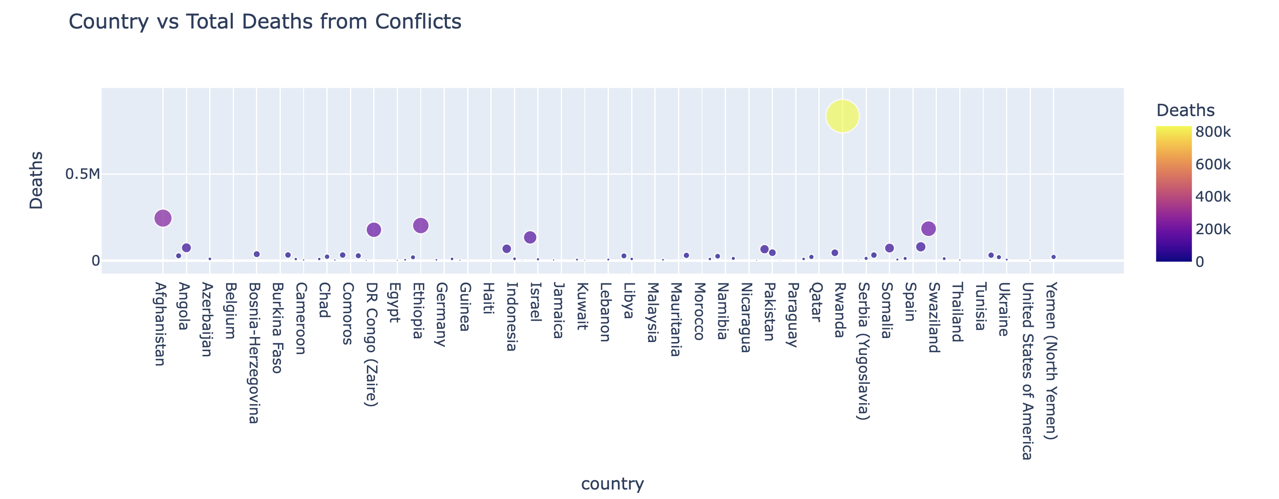

The individual conflicts events by total deaths is broken down below, keep in mind this isn’t a grouped count of the total deaths, but a look at conflicts with high levels of deaths in individual events.

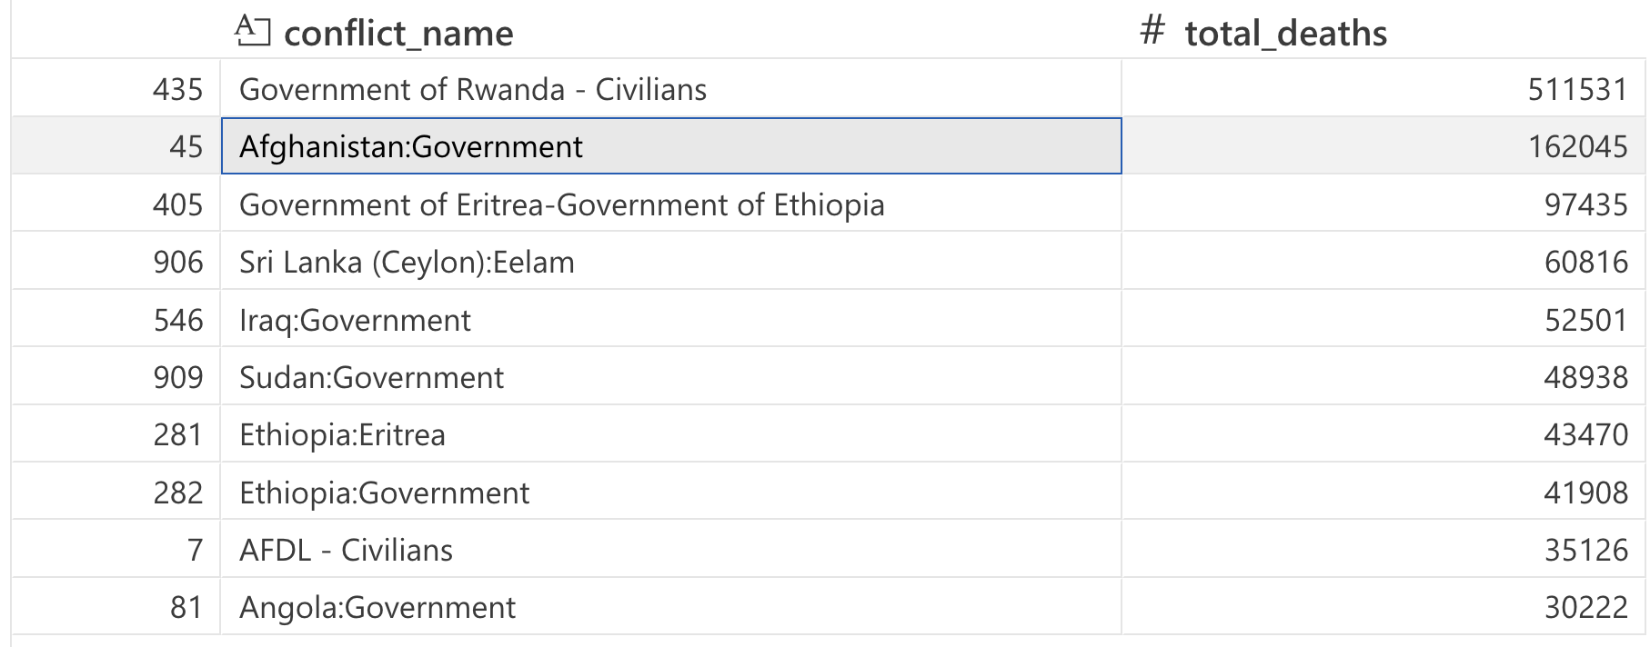

It is important to note, the categorical variables in this dataset contain many unique values, so when needing to convert to numerical data with methods such as hot one encoding, the dimensionality becomes too large. The unique value counts can be seen below.

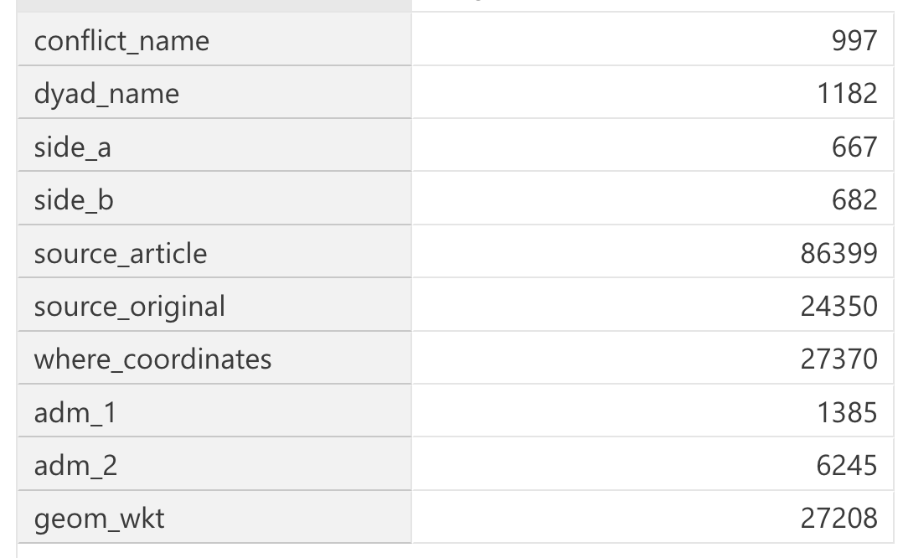

Finally, 10 countries made up 57% of the conflicts in the entire dataset, and here is how it breaks down, with Afghanistan being number 1 with roughly 22.7 thousand conflict events.

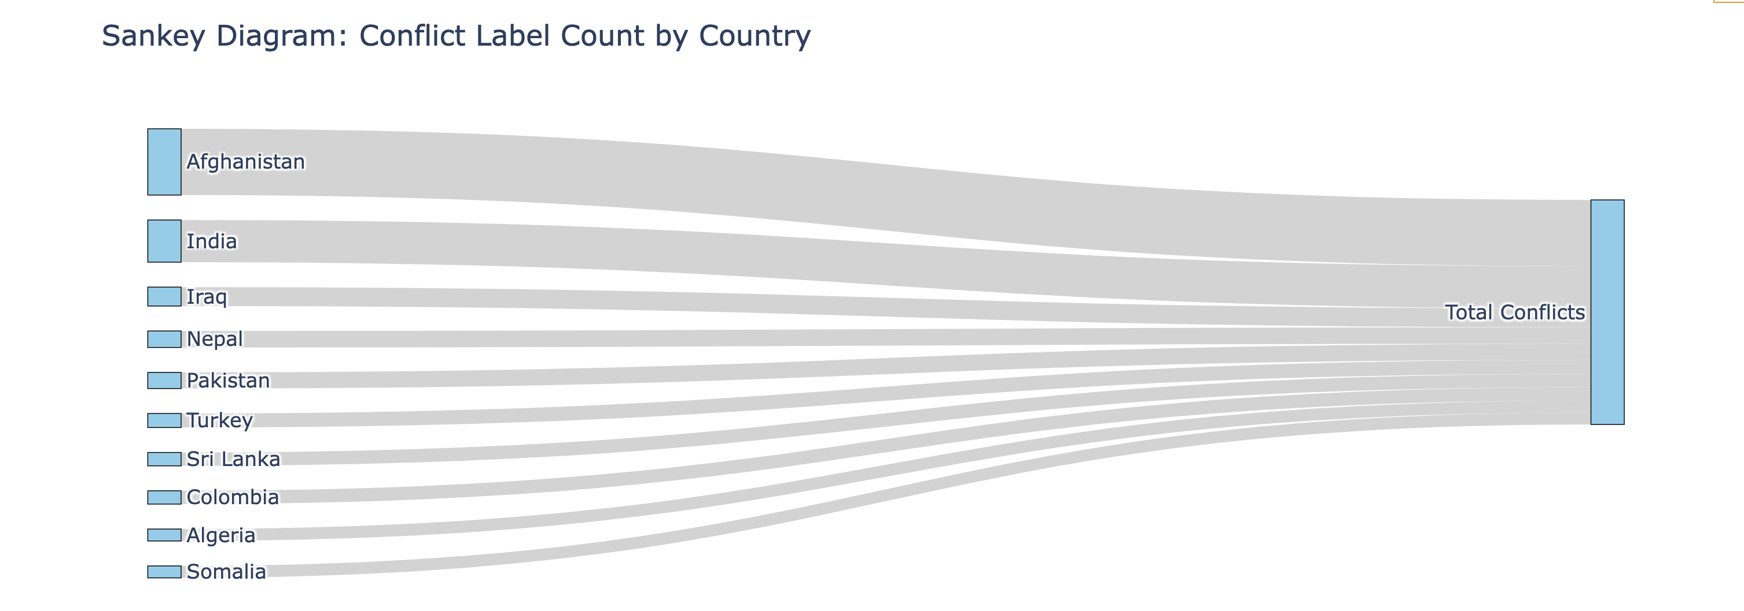

### Data Mining and Methods

### Clustering

The goal of clustering is to group similar datapoints together, and in this case to group similar conflicts together. The dataset is structured as each datapoint being an event in a greater conflict, so we are clustering individual battles as well as conflicts. By doing this, and finding similarities, studies can be done to find common patterns among them. Common patterns such as what started the conflicts, where they occurred, who was involved and how many deaths came as a result. Once these groups and patterns are identified, we can learn from the patterns and find ways to mitigate or predict these conflicts occurring in the future. This dataset generally revolves around the location geographically, the number of deaths, who was involved, and how it was reported, in order to find deeper patterns, it could be beneficial to join in an additional dataset providing more context around these conflicts.

For most clustering algorithms they typically only allow numeric data as input variables. This dataset however included a substantial number of categorical variables. Now there are ways around this such as hot one encoding, ordinal encoding or label encoding. Ordinal encoding only really provides value if there is a hierarchy in the data, such as ‘high’, ‘medium’, ‘low’, turning into ‘1’,’2’, and ‘3’. In the case of this data, that was not applicable. Label encoding is similar in a sense that it only really provides value if you have a smaller number of unique values. It assigns each category a number, but if you have 28,000 categories, it doesn’t provide much value in predictions. Lastly, hot one encoding creates a new column for every category in the column, and adds a 1 or a 0 meaning it applies to the row or not. The issue with this is an increase in dimensionality, and in the scenario of this data with 100,000+ unique values in the categorical columns, that is an unrealistic amount of processing and noise to have a dataset of 100,000 columns. There is the option of utilizing gowers distance, but in this case, I decided to omit the categorical columns all together and only focus on numeric. This allows us to see true similarities on conflict and avoid clustering conflicts together simply based on geography.

I attempted to cluster with DBSCAN and Kmeans, and did not have great performance with either, but Kmeans performed the best. I measured performance using silhouette score which measures how well the groups are clustered and the distance between them, with 1 being the best score and 0 showing overlapping clusters.

With a dataset this large, containing over 135,000 entries of different battles/conflicts, we can’t expect there to only be 2 or 3 clusters that they all fit into as they are all so vastly different. The size of the dataset requires quite a bit of compute power to perform algorithms, so to find the optimal number of clusters, I performed mini batch kmeans clustering. Mini Batch Kmeans Clustering takes small sub samples and performs kmeans without having to process the entire dataset, significantly speeding up the process. After a few iterations of narrowing, it down, and using the within cluster sum of squares metric, I found the optimal number of clusters to be around 6100.

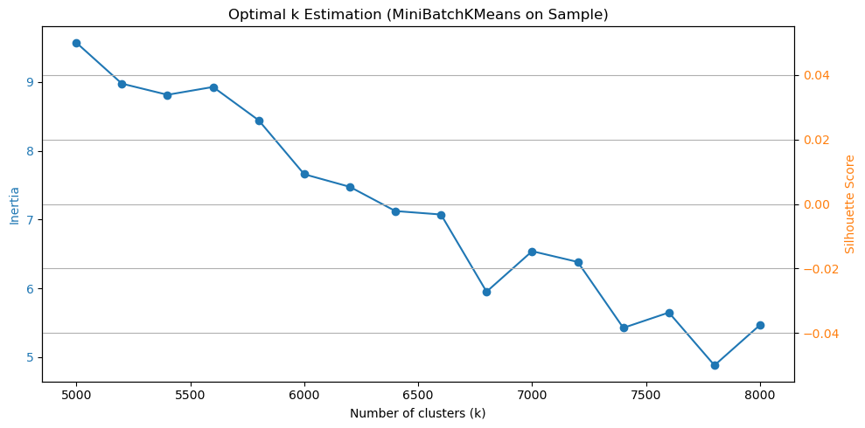

When dealing with this large amount of clusters, it is very difficult to visualize and have clean cluster groupings on the plot, even after Principal Component Analysis. However, the silhouette score came out as n_clusters = 6100, and the silhouette score is: 0.3943378451694663, which isn’t the best, but the model is clustering decently. Below we can obviously see quite a bit of overlap, but the restrictions of the plot size doesn’t help either.

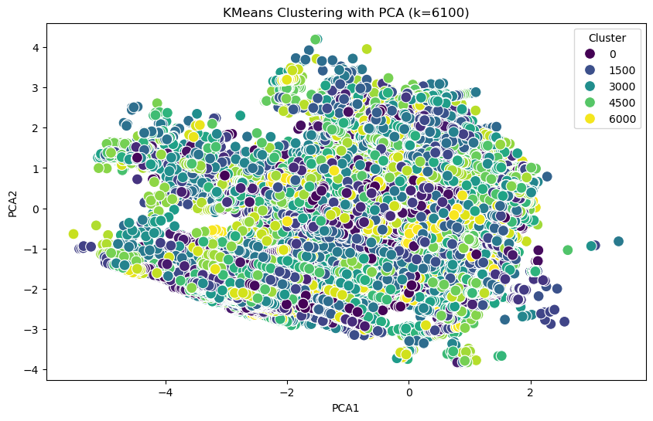

If we take a plot of all the conflicts by labels or clusters, again with over 6000 clusters, it is very difficult to really make much out, there are not 6000 colors we can pick from to easily distinguish, so we must go based on the legend and the shade of the color. Labels are grouped all over the world, not just geographically which was the goal. I did not want the main factor of the clustering to be based solely on geography, but by the contents. However, if you look at the second image below, the model does a pretty good job at clusters the conflicts in the same cluster (around the 4000 range) in the light orange. This, I would expect as Rwanda’s conflicts were so vastly different from others. Below I will dive more into the Rwanda’s conflicts and how they were clustered as an example.

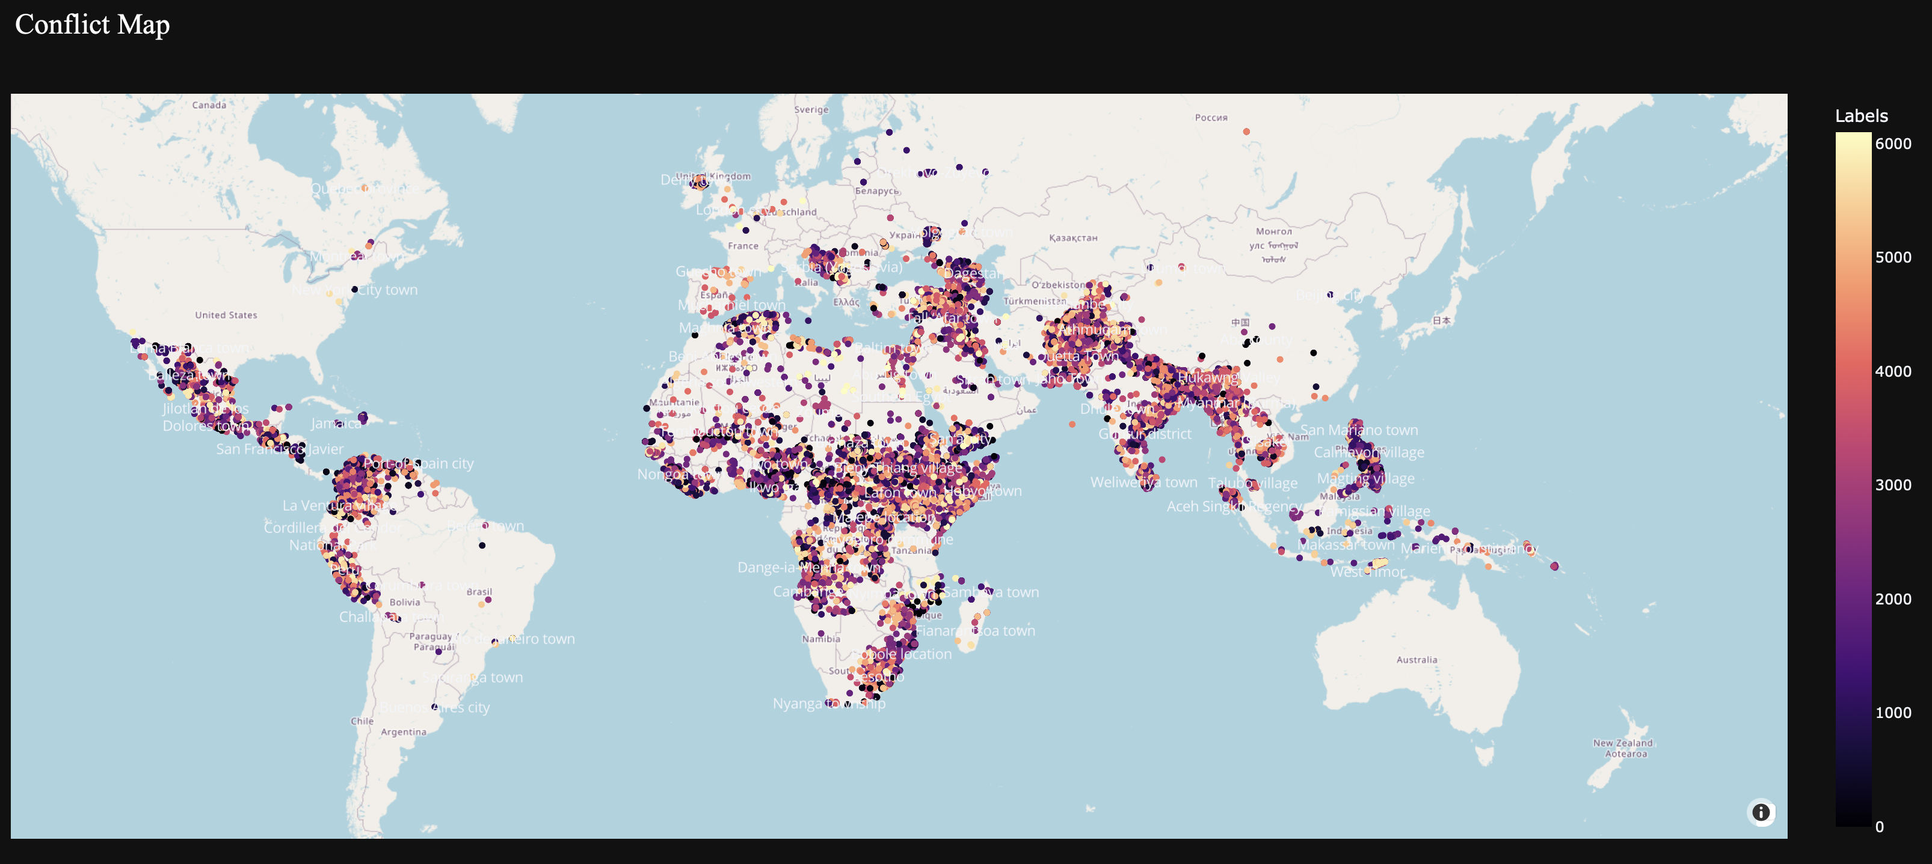

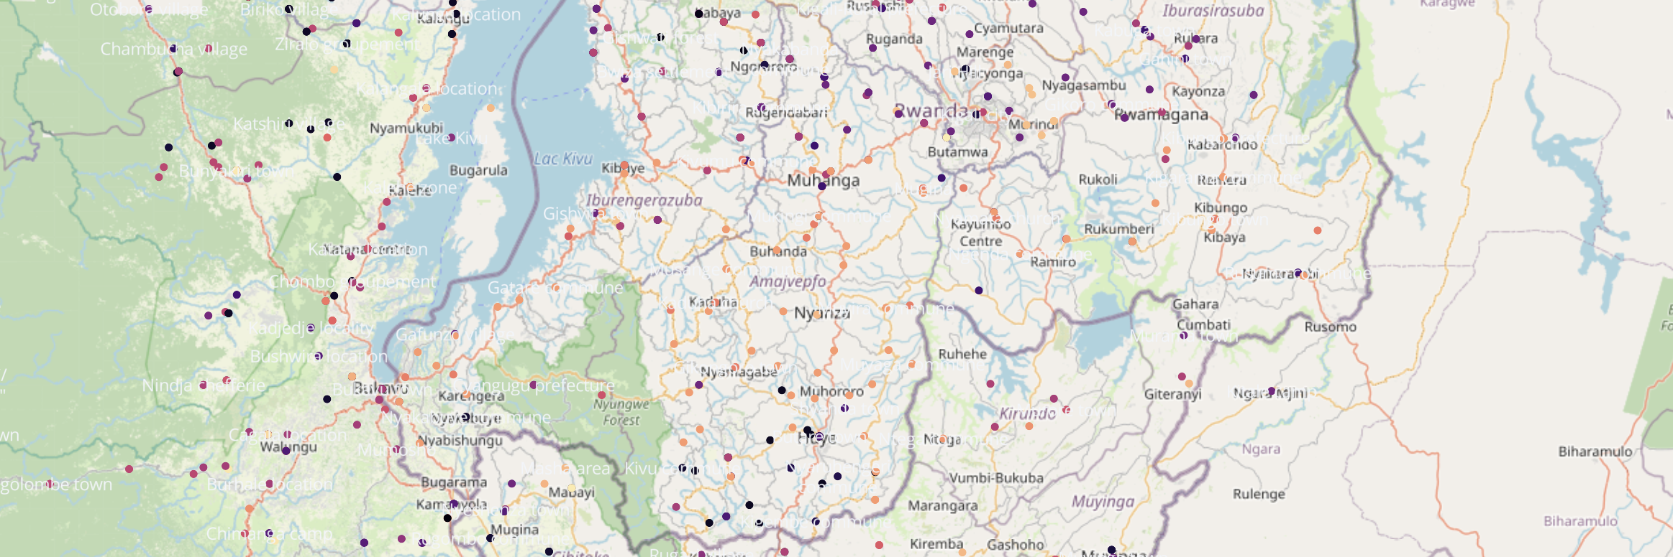

Below are the labels with the most deaths, as we can see here even though it clustered a lot of the Rwanda conflicts similarly, the conflict of Rwanda and Civilians was split into multiple labels. Even though it is the same conflict, the battles inside of that conflict also had a bit of variance. The first on the list, label 5862, made up of 6 events, accounted for 323,984 deaths, or 54,000 per event.

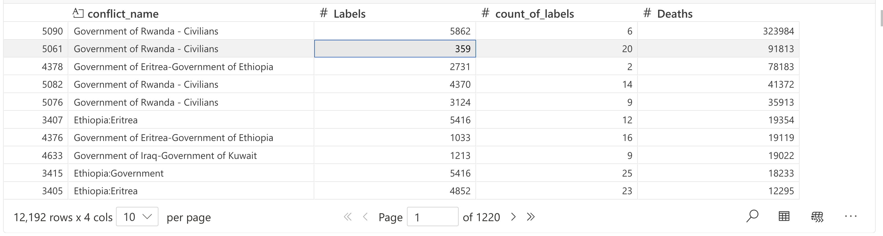

This displays the conflicts with the most variance in events, or the most labels/clusters in it. The counts or number of labels is on the y axis, the actual label number itself is on the x axis, and when hovering over each point, it gives the conflict name and the values. It is an interactive visualization, so it is impossible to see here, however the conflicts with the most labels are Somalia vs Government and Government of Indonesia vs Civilians

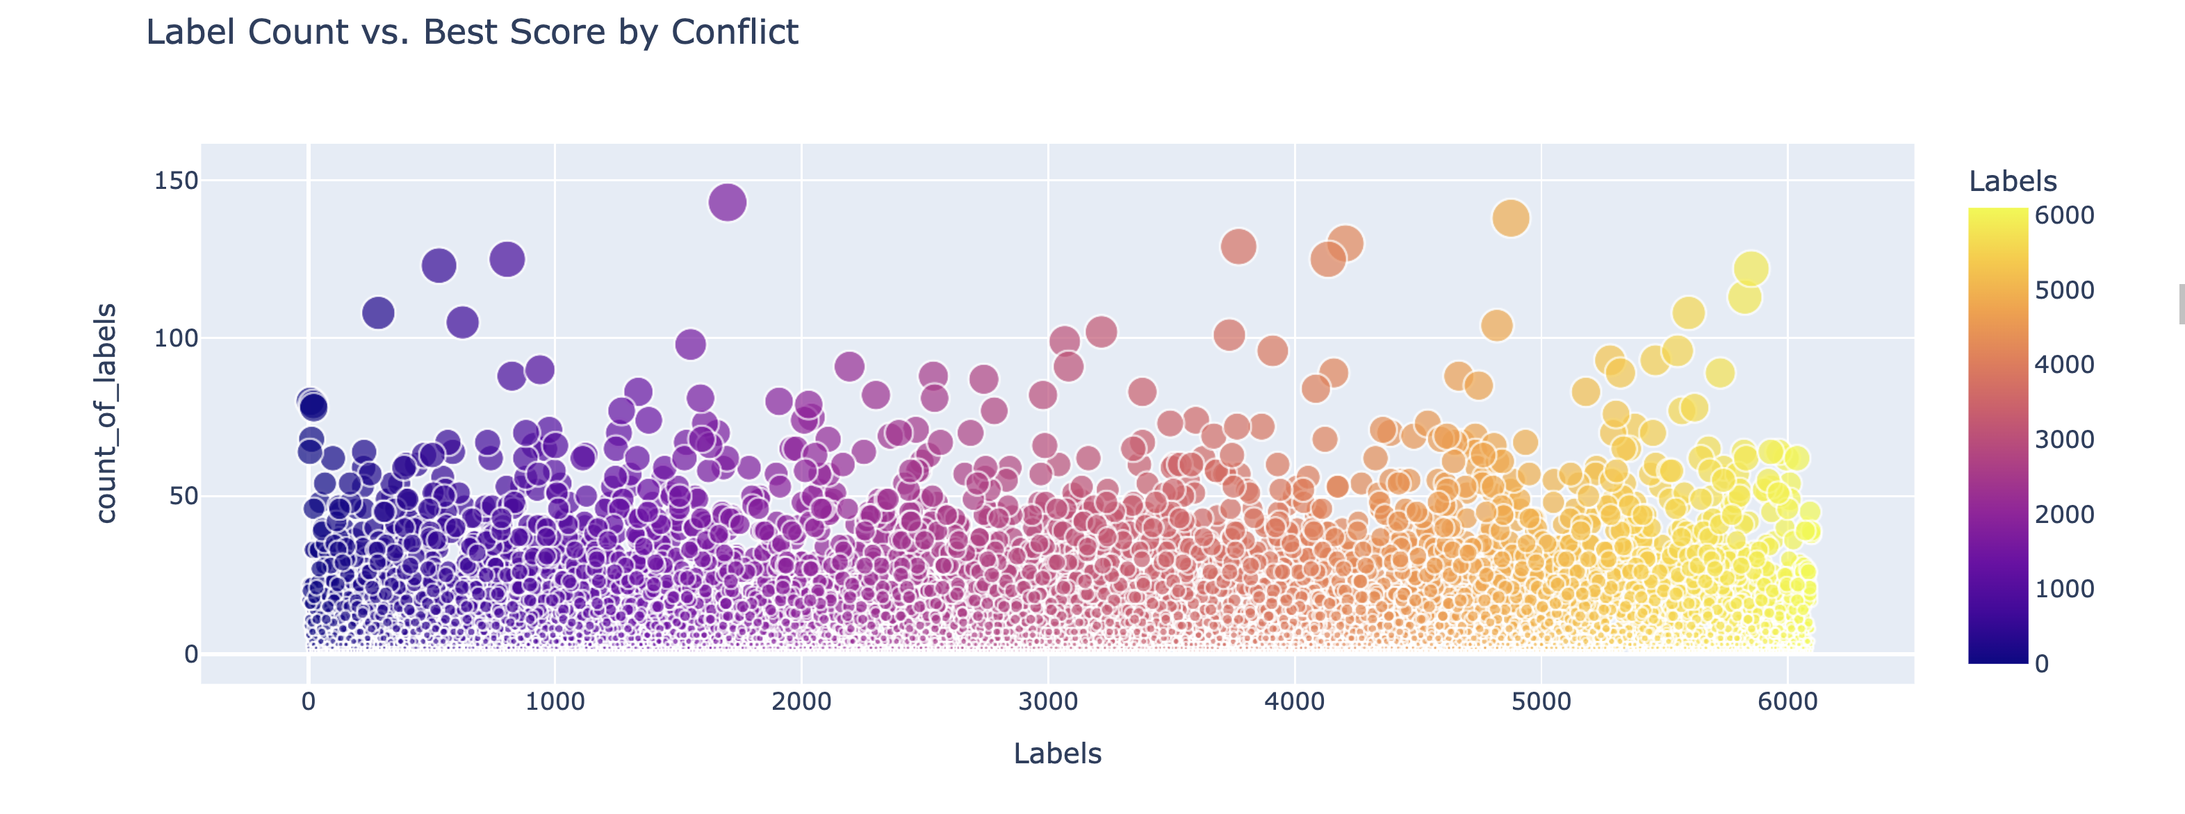

Here is another view of the conflicts and deaths by label, 320,000 of the government of Rwanda conflict were labeled in the same cluster.

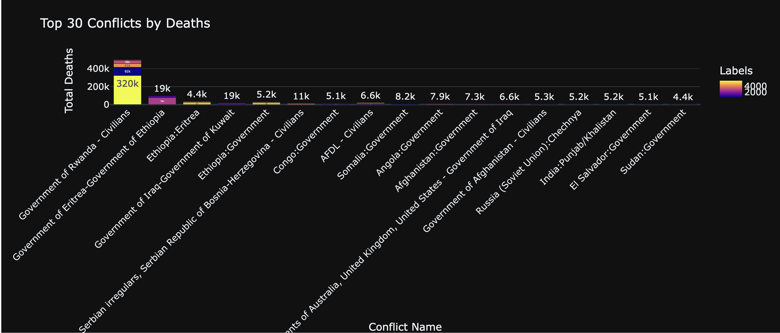

### Sentiment analysis and results

This dataset includes a column ‘source_article’, containing article contents with a summary of what was reported on each conflict event. I chose to perform sentiment analysis on this specific variable, to see if I could gather the general outcome of each conflict event based on the article title. The problem with some traditional sentiment analysis is that it returns either a result of ‘positive’ or ‘negative’, which in terms of conflicts, everything will typically return as ‘negative, and does not provide us much value. So, I chose to use hugging faces pretrained LLM "j-hartmann/emotion-english-distilroberta-base" for text-classifcation, returning one of the values in ‘neutral’, ‘sadness’, ‘fear’, ‘disgust’, ‘joy’, ‘anger’ or ‘surprise’.

The results below align with what I would be expecting for the most part. Interestingly enough, the model focused on the tone of the article, assigning ‘neutral’ to over 60,000 of the entries. When considering these are news articles, and their job is to be objective in their reporting, a neutral tone is what would be expected. Sadness coming in second with just over 40,000 entries also makes sense, as the articles are about conflicts and tragic events unfolding. The surprising sentiment is joy, there are not many but it still occurs.

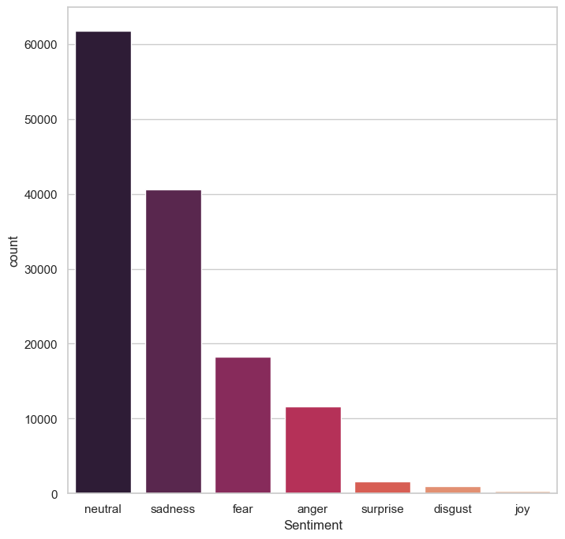

When digging deeper into **joy** below using a word cloud, or a collection of all the words used in each article, nothing really sticks out as to what would make the model think these are joyful events. However, when we look below, at the word cloud of the anger sentiment it makes more sense. Comparatively, the language used in the joy articles are substantially more neutral than those used in the articles with anger. Though if one was planning on using a model to classify contents based on articles written, there would have to be some human intervention. Imagine having a news app and classifying in article as ‘Joy’ in the homepage, and someone clicks on it and it about a war involving conflict and death. This probably would not go over well with readers.

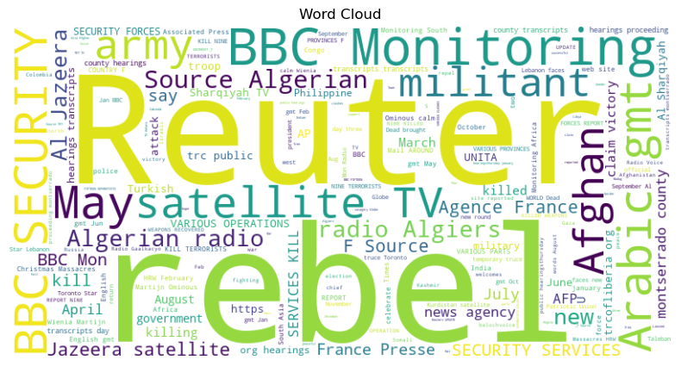

The contents of those labels as **anger**…

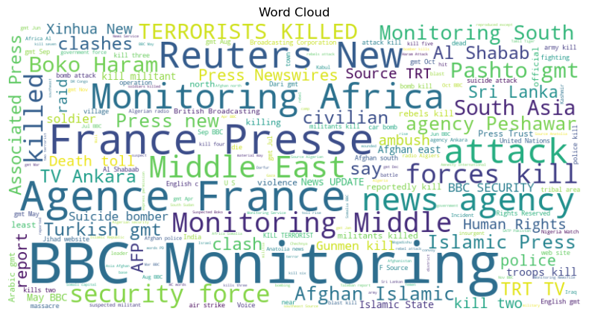

### Predicting

For predictions the goal was to predict for ‘**high’** which was the high estimate of the total deaths involved in each conflict. None of the models except a sequential neural network performed well predicting for this variable, but over the course of training I realized the model would perform better when predicting for ‘**best’**, or the best estimate of total deaths from the conflict (both are numeric variables, so I used regressors). The model I settled on can predict for both, but no pun intended, they performed the best on ‘best’.

I originally tried some rigorous data cleaning and hyperparameter tuning to get the traditional statical models such as decision tree, random forest, linear regression and xgboost to perform. Using several different methods of data cleaning, binning and then label encoding due to the large number of categories, imputing nans with KNN imputation for numeric and most frequent for categorical, filling with missing/nan as well, and scaling to no avail. The best performance I got on statistical models was below using a decision tree, which is not sufficient to put a model into production and was still suffering from overfitting even after hyperparameter tuning with homemade testing as well as the help of gridsearchcv.

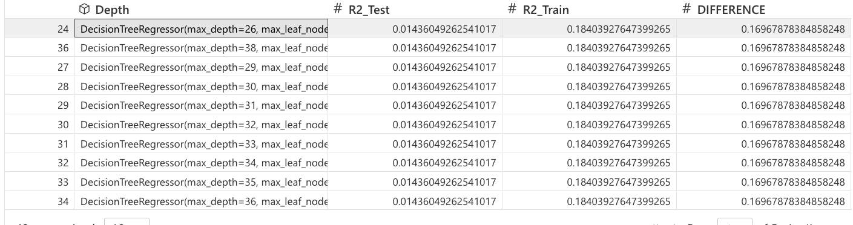

So with that being said, I went back to the basics of data cleaning and preparation and went to my last hope of a neural network. By the basics I mean instead of using KNN imputing, binning, dropping unique columns and NAs etc., I simply imputed NaNs of the numeric data using the median value, and the categorical data with the mode. I then label encoded categorical data. I also dropped highly correlated columns as well as those that were directly associated with our target, in this case ‘best’, then scaled the data and threw it into a sequential neural network. Immediately, we had progress, producing something like 65% R^2 on the testing and 90% on the training, which obviously is severe overfitting. In order to mitigate this overfitting, I included 3 dense layers in my sequential model, not including the input and output layers. Each included 64 neurons, a relu activation function, and kernel regularizers with l1 and l2 and dropout. After a few iterations of tuning these parameters, I ended up with the results in the screenshot below. We can interpret this as the neural network taking the input dataset and passes it through three layers each with 64 neurons. The layers are all connected so each input is linked to every neuron in the next layer, and the parameters it learns are weights and bias terms. For example, with 41 input features, 41x64 neurons + 64 bias terms on for each neuron, = 2,688 parameters and so on. Dropout layers as you can see don’t add parameters but only drop them.

### Performance

As shown below, this model is performing at an accuracy or R^2 (explanation of variance in the data that accounts for both scale and size) of 95.3% on the test data (or unseen data) and predicting 98.5% on the training data. This is slight overfitting but in my opinion, it is acceptable. It is not just directly generalizing on the training data (or only learning on that specific data) but transferring what it has learned over to unseen data. Now some people may see this and say there must be another variable with a direct link to the target variable that is allowing it to predict that well. For example, if we had a column of deaths_a and deaths_b and best was just the sum of both. In a model we don’t want this direct link as we want it to be able to predict based on pattern of data that doesn’t directly explain the result. Anyone could sum up the other two columns and get the result for example, that isn’t really a prediction. In this case I removed all the columns that were in anyway related to my target, as well as removed any of the columns with multicollinearity. Hence the predictions were based on non-directly linked patterns. With all that considered, I believe this model could perform well in production and be used for things such as prediction of conflict outcomes based on who is participating, where and when it is occurring, which could help organization such as the UN interfere in the most extreme before they occur.

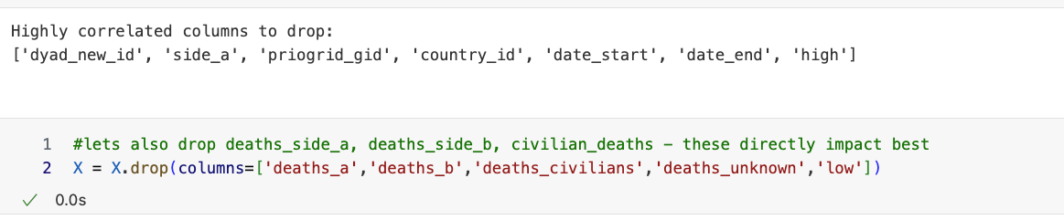

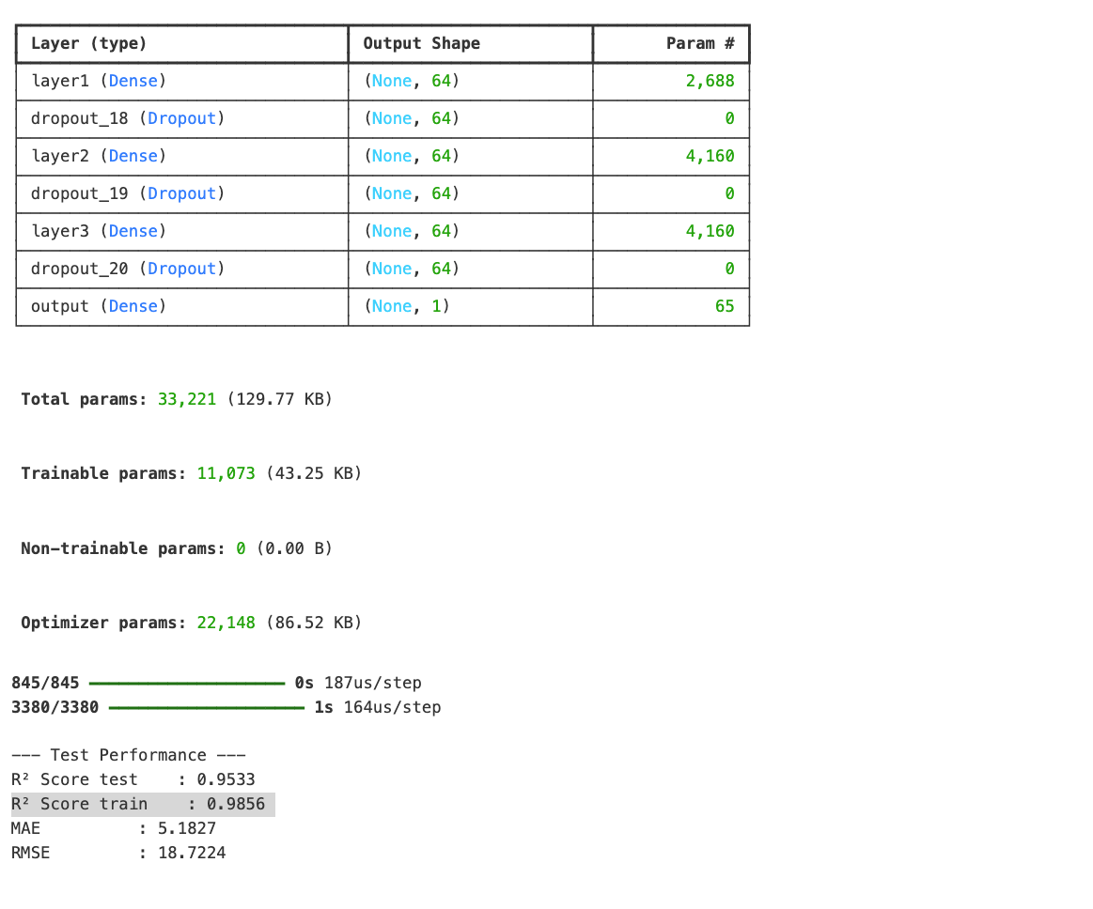

### Summary

In summary, this there was a lot of good insights to be gained from this dataset. From an analysis or datamining perspective, it would be good for building an analysis on the facts of conflicts spanning back to 1946. Such as which countries have the most conflicts, which conflicts and countries have the most deaths, which sides fight the most and so on. This dataset can also be used for clustering similar conflicts together, to get an idea of where to start looking to find deeper patterns in each. For example, if we saw that conflicts in Ethiopia were very similar to those in Columbia, and if there were other datasets available it would be possible to investigate things such as the government, political actors, socioeconomics etc. in each place and see what overlaps to discover a pattern causing these conflicts. Furthermore, using the sequential neural network, we can accurately predict the outcome of these conflicts in terms of death toll. In the future as conflicts arise, this can be used to predict the severity of an impending conflict and allocate resources in order to interfere or stop them before they occur. If we know based on the prediction that conflict X probably will result in significantly less causalities than conflict Y, and there is a small number of resources available, they can be properly allocated.